**Testing Aces**

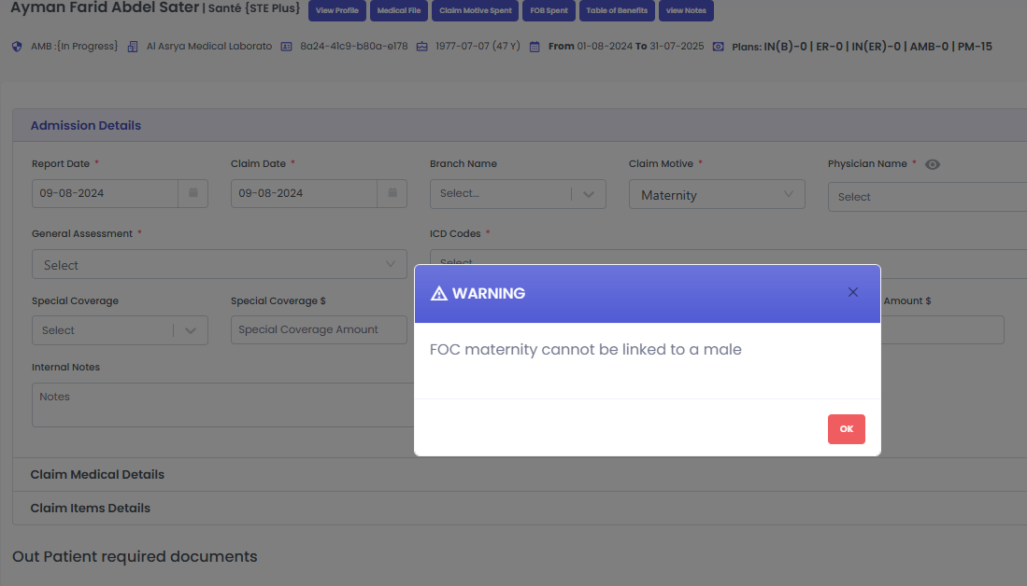

* The system notified me well that the claim motive selected is not applicable with the gender of the patient.

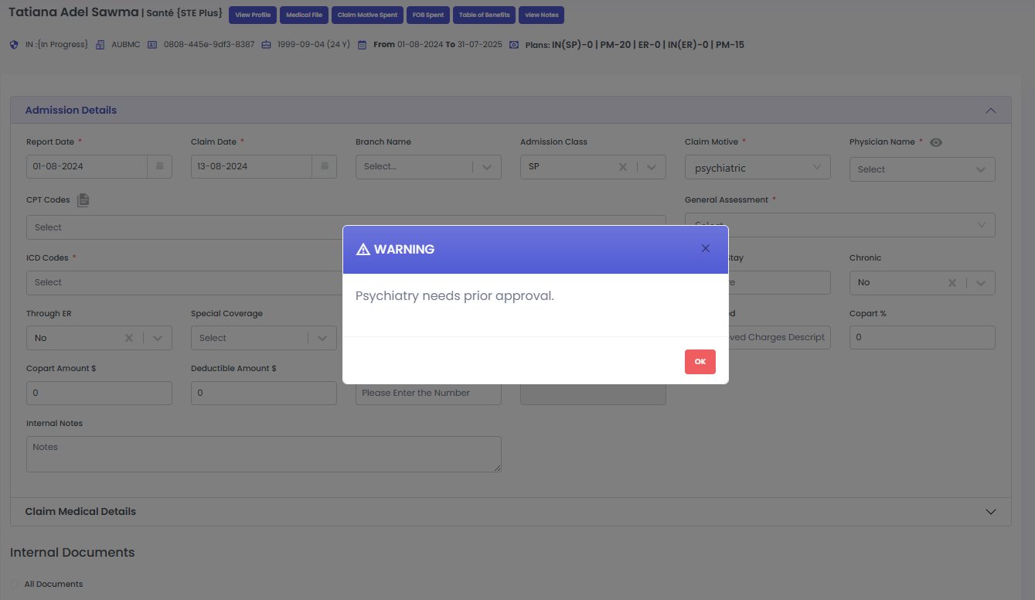

* The system notified me well that the claim motive selected needs prior approval

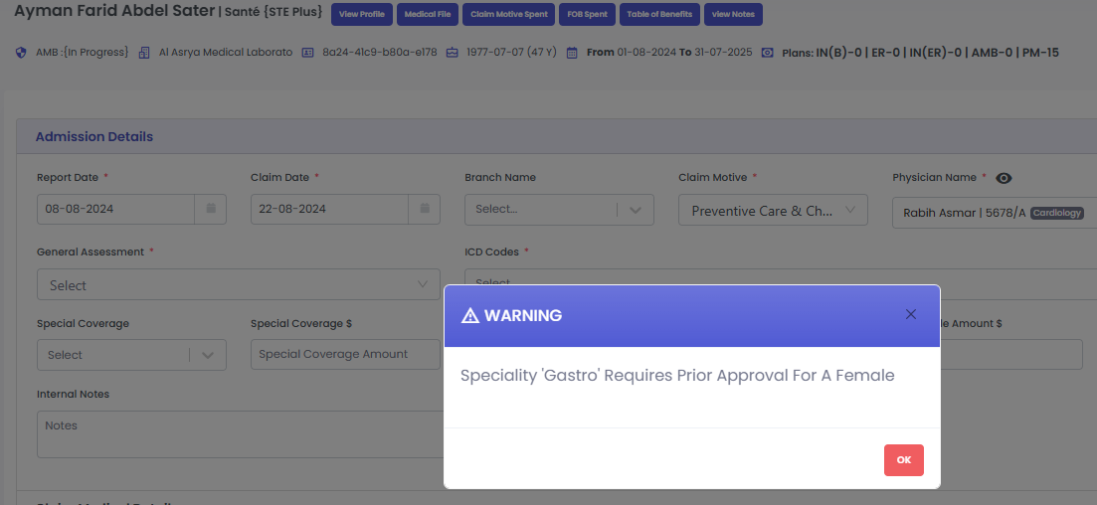

* The system sent a wrong warning saying that the gastro specialty requires prior approval for a female, even though the doctor selected is a cardiologist not a gastrologist.

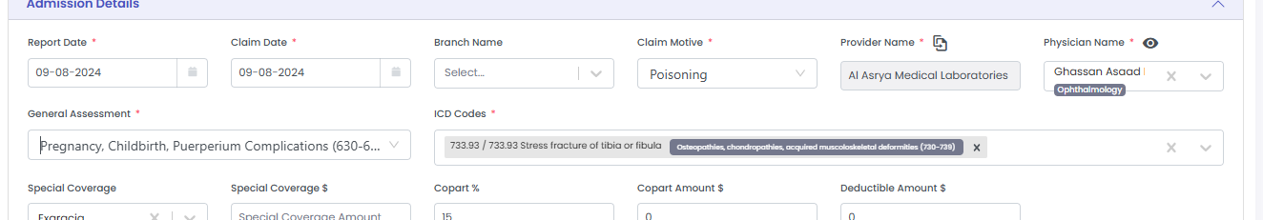

* I changed the claim motive and placed a valid one, and I selected pregnancy as a general assessment, the system did not alarm or notify me that the general assessment is not applicable for a male.

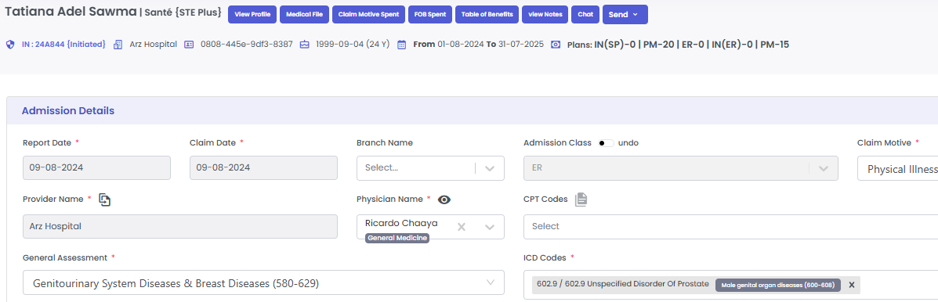

* Same as the previous note, the system did not give any warning that the ICD placed (related to prostate) cannot be placed and does not applied for a female.

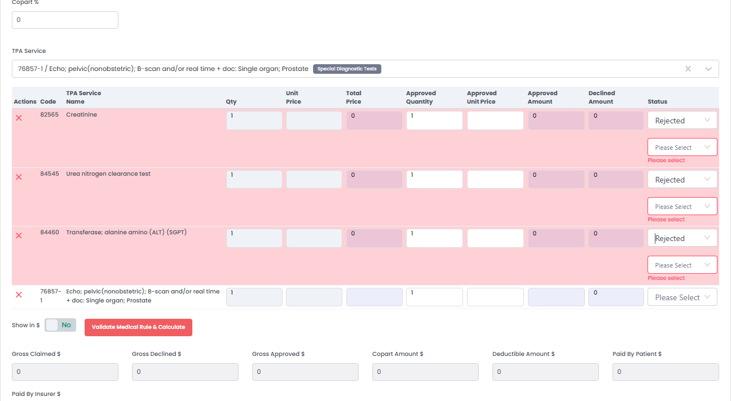

Not sure if this is because no unit price is inserted in the first place, but when clicking on “Please Select” (Status) and choosing anything other than the rejected option, the system is directly placing it as rejected.

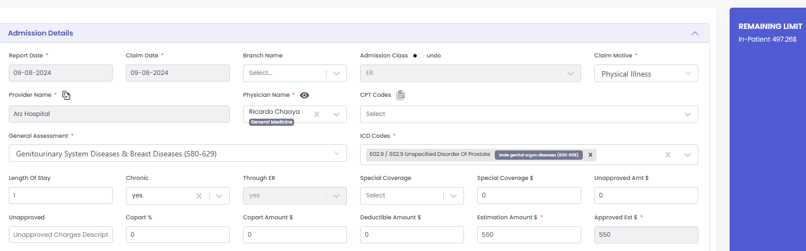

No warning sent by system to notify that the estimation amount exceeded the limit.

BUT, after pressing “Enter” the system calculated and notified that the amount cannot be greater that the remaining limit.

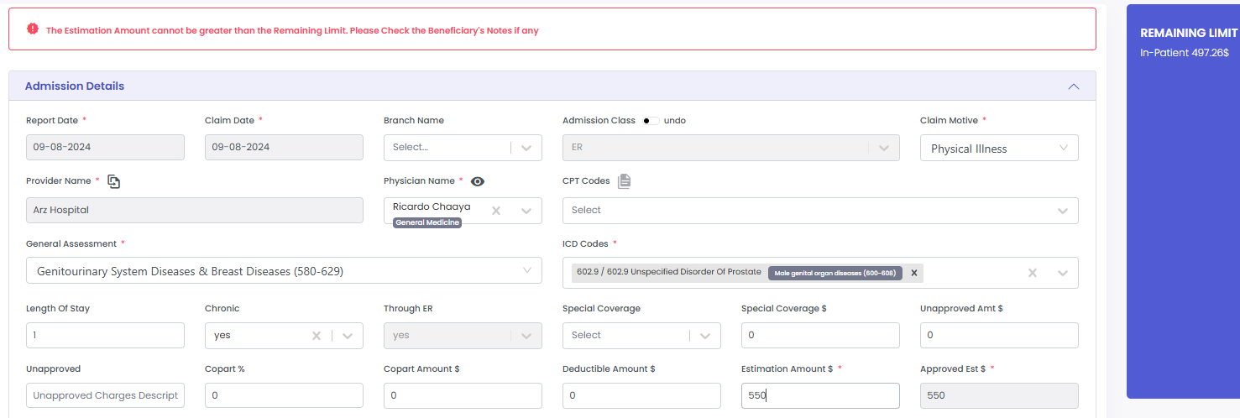

Done by: Mira Abdel Nour

Date:9/8/2024